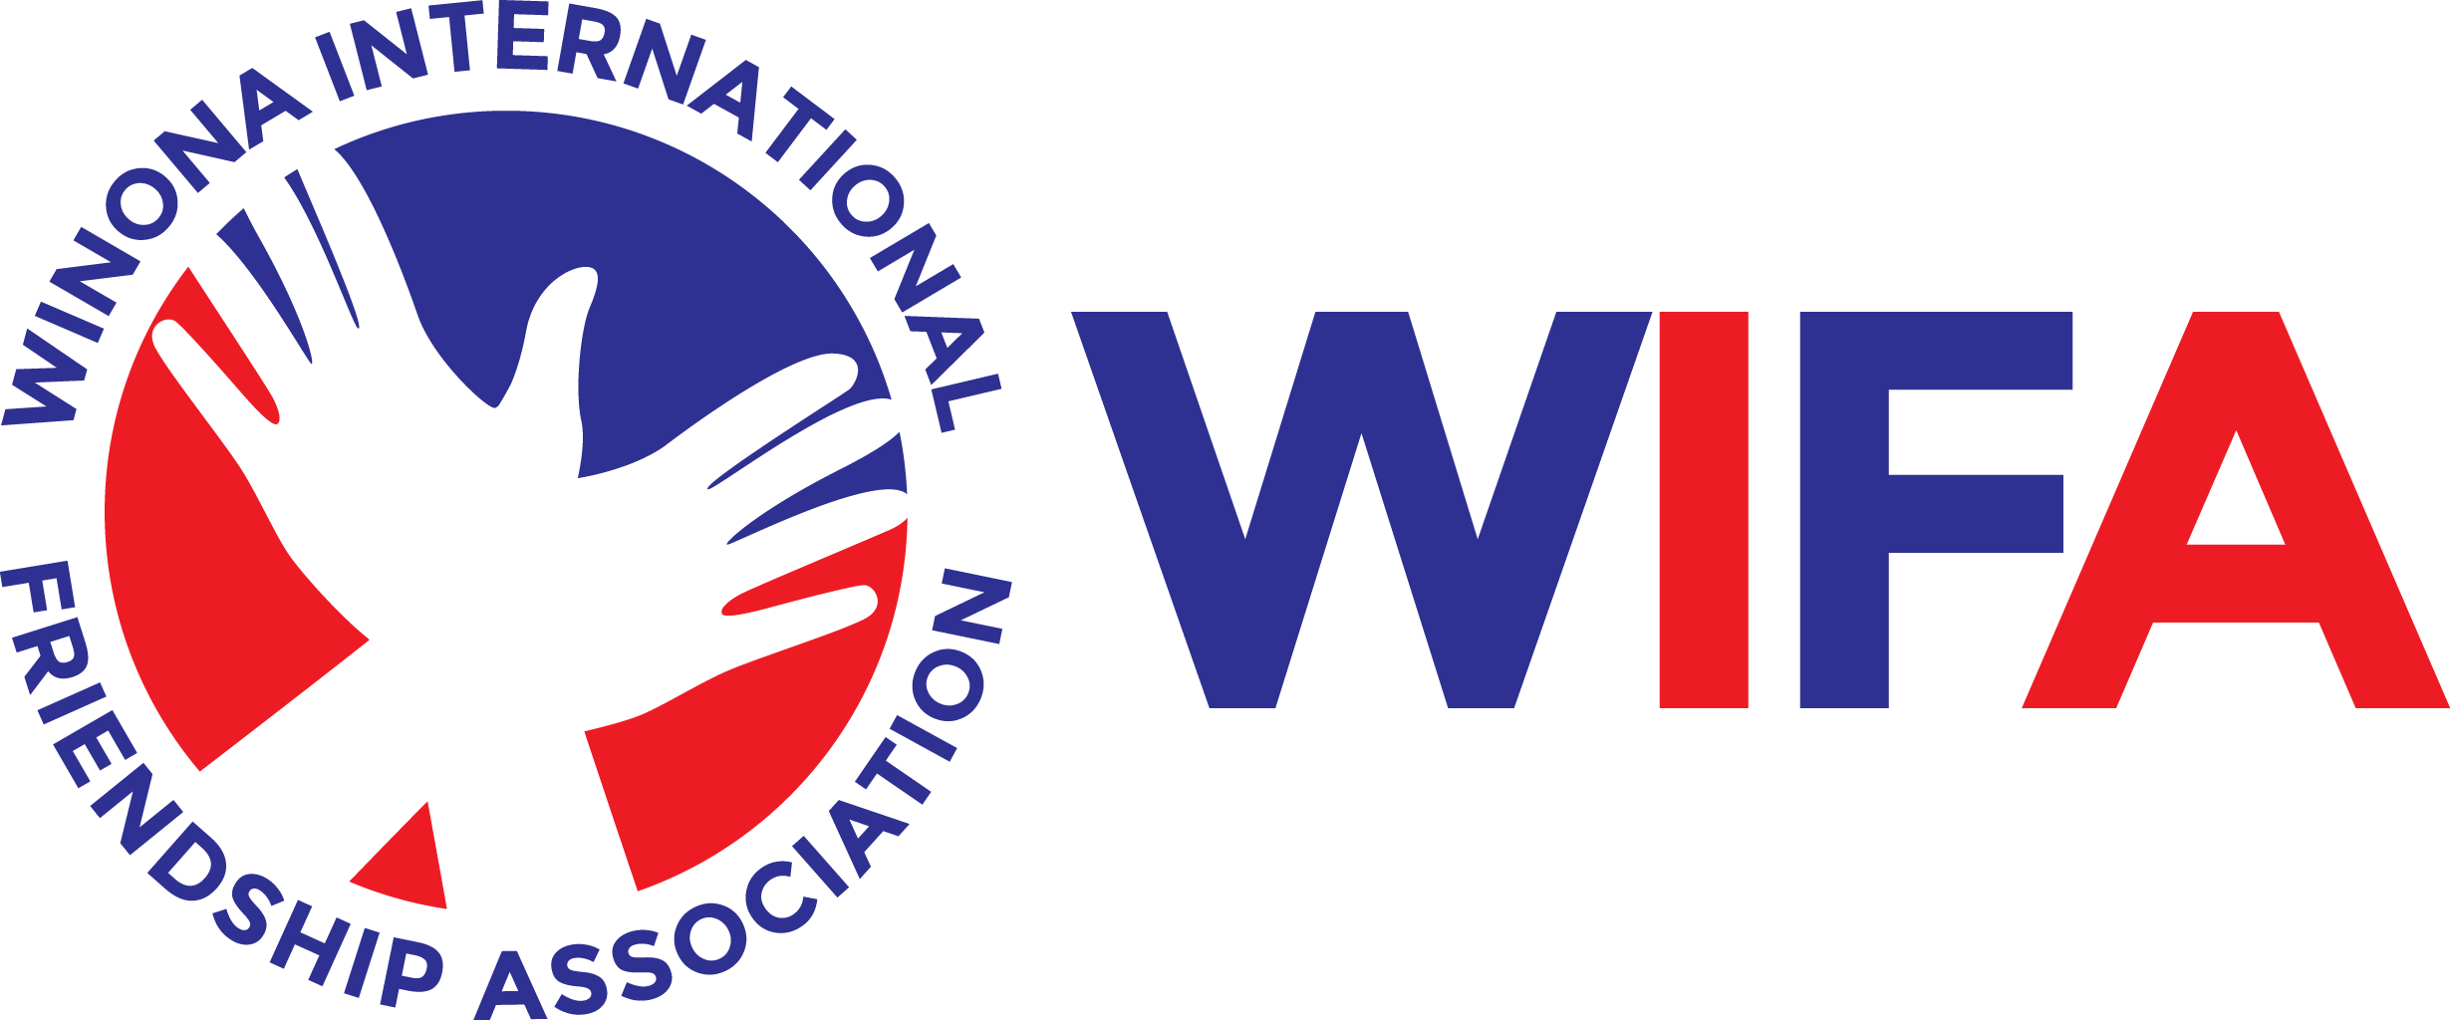

Travel and Ambassador Profile
Please turn this form in with your phase one application materials by July 24.

Personal Information

Name

Date of birth

E-mail address

Phone number (note home or cell)

Address

Emergency contact (name & number)
Passport—Copy of passport would be accepted | Leave blank if you do not have a passport

Country of birth

Name as it appears on passport

Country of citizenship

Number

Expiration date

Student and/or community involvement activities and interests:

All ambassadors & families are expected to engage in the following:
Participate in fundraising events | Host a Misato student in your home from October 8-12, 2026
Be an ambassador for the program | Continue to be an engaged student
Attend training meetings | Continue to support the program after your tenure

Student signature: ________________________________________ Date: ___________________

